Phone Clearing Exercise
On June 24th 2026 I cleared out the data on my phone in preparation for the SIM being replaced.
Funny thing, while I was clearing out my phone I came across some photos that I didn’t take. Now, I told you in previous videos I suspect that my phone has been cloned. I’m wondering if there is some connection when someone clones you phone if the photo reels get meshed in some respect.
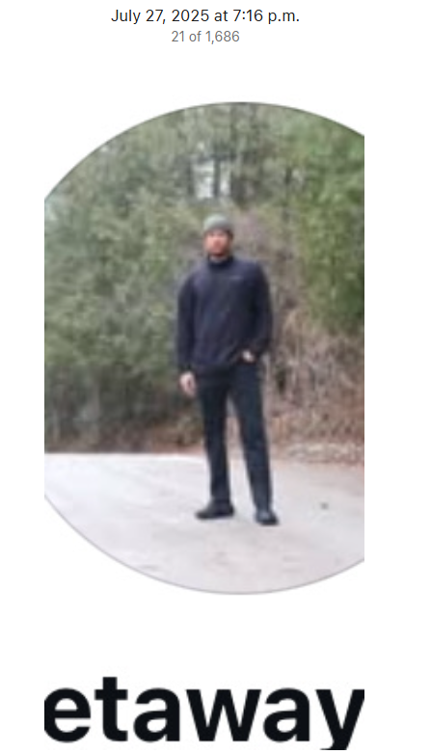
These photos include one of my ex (July 14th 2025), and 2 people that I don’t know (July 24th and July 27th) that look like screenshots. These pictures are included below.
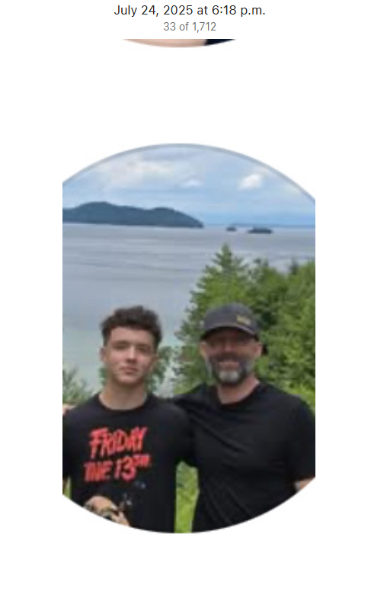


Internet Issues
While going through this exercise, it was discovered that both my cellular and my Google home Devices were super slow (I have Google home networking devices) BUT, I have discovered when I connect directly to the Bell network, I am able to transfer things around with relative ease.
Deductive reasoning – I think that my Google accounts may be compromised.

